ServiceNow-Based Employee
Licensed Software Installation Application

Project Documentation

Platform: ServiceNow (Global Scope)
Module Type: Service Catalog / Catalog Item / Flow Designer
Team Members: [Add team member names and roles here]

1. Introduction

Project Title
ServiceNow-Based Employee Licensed Software Installation Application.

Team Members
[Add team member names and roles here]

Platform Overview
This project is built entirely on the ServiceNow platform using out-of-the-box (OOB) Service Catalog and Flow Designer capabilities in the Global application scope. Unlike a traditional MERN-stack build — and unlike a custom scoped application — the 'frontend', 'backend', and 'database' layers here are all native ServiceNow constructs: a Service Catalog Item for the UI, a Flow Designer flow for server-side approval/fulfillment logic, and standard ServiceNow tables (sc_req_item, sc_task, sysapproval_approver) for data storage — no custom table was required.

2. Project Overview

Purpose
The Licensed Software Installation Application allows employees to raise a request for licensed software (e.g. Microsoft Office, Adobe Acrobat, Visual Studio) directly from the Service Catalog. The request automatically routes to the Software Manager for approval, and — once approved — a fulfillment task is created for the IT Software Support Team. The goal is to digitize and standardize what would otherwise be an ad-hoc, email-based software request process, while keeping full visibility over license usage and installation status.

Key Features
- A Service Catalog Item ("Licensed Software Installation") that presents a structured request form to employees.
- Six request variables — Software Name, Software Version, Installation Device, License Type, Business Justification, and Required By Date — captured on the standard Requested Item (RITM) record.
- An approval workflow built in Flow Designer that asks the Software Manager to approve or reject each request.
- Conditional branching in the flow — fulfillment only proceeds when the approval state is Approved.
- Automatic Catalog Task creation ("Install Licensed Software") assigned to the Software Group / Software Manager on approval.
- Live status tracking on the Requested Item — Approval state, Stage, Quantity, and Delivery Plan.
- Centralized, auditable approval history on the Approvals list, filterable by approver.
- All configuration changes captured in a dedicated Update Set for safe promotion between instances.

3. Architecture

The application follows ServiceNow's standard three-layer model. The table below maps each MERN concept to its ServiceNow equivalent used in this project.

Layer | ServiceNow Equivalent
Frontend (React) | Service Catalog Item + native Order/Request form UI
Backend (Node.js / Express) | Flow Designer flow ("Licensed Software Installation - Approval and Fulfillment")
Database (MongoDB) | Standard tables: sc_req_item, sc_task, sysapproval_approver (no custom table)

3.1 Application Scope
All components (catalog item, variables, flow, and update sets) live in the Global application scope rather than a dedicated custom scoped application. This keeps the solution simple to build and deploy for a single, focused catalog process, though a custom scoped app (as used in larger implementations) would be a reasonable next step if the solution grows to include custom tables, roles, or business rules.

3.2 Data Model — Catalog Item Variables
Rather than a custom table, request data is captured through catalog item variables that populate the standard Requested Item (RITM) record. Each variable is defined with a Type and Order that controls how it renders on the request form.

Question (Variable) | Type | Order
Software Name | Select Box | 100
Software Version | Single Line Text | 200
Installation Device | Select Box | 300
License Type | Select Box | 400
Business Justification | Multi Line Text | 500
Required By Date | Date | 600

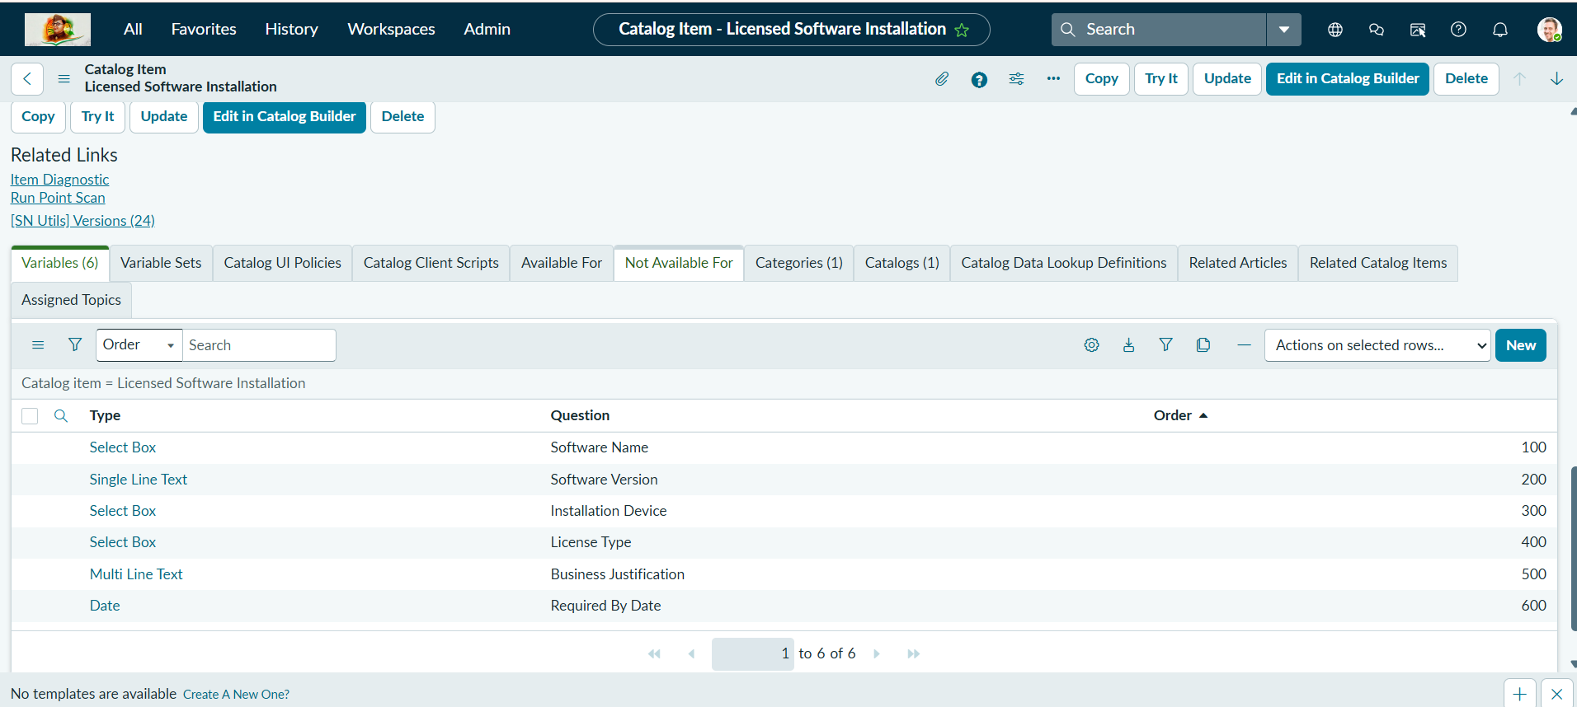
Figure 1: The 6 variables defined on the Licensed Software Installation catalog item.

3.3 Catalog Item — Employee Ordering Experience
The "Licensed Software Installation" Service Catalog Item is the ServiceNow equivalent of a public-facing intake form. It collects the software name, version, installation device, license type, business justification, and required-by date, and on submission creates a new Requested Item (RITM) record.

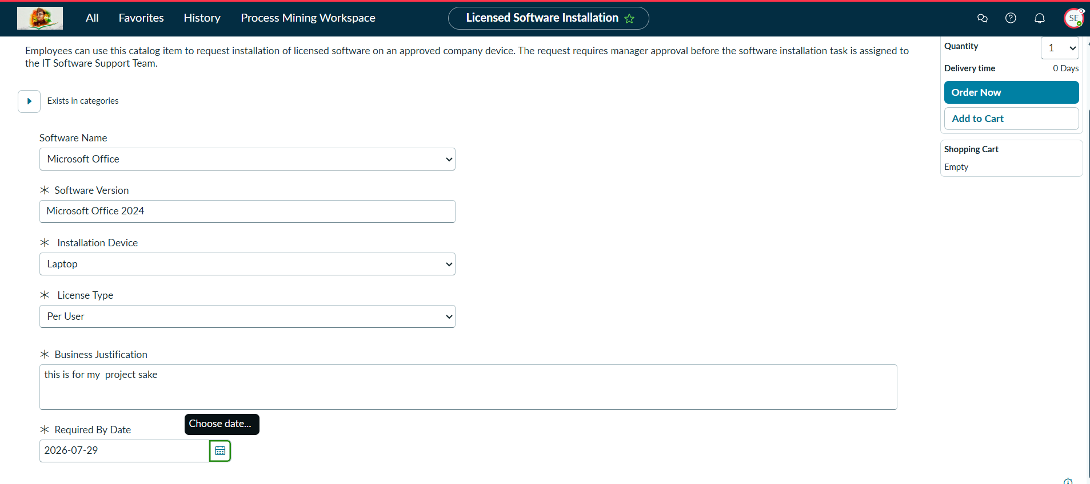
Figure 2: Employee-facing catalog item request form.

3.4 Flow Designer — Approval and Fulfillment Workflow
The "Licensed Software Installation - Approval and Fulfillment" flow is triggered whenever a new item is ordered through the Service Catalog. It asks the Software Manager for approval, checks the approval outcome with an If condition, and — when approved — creates a Catalog Task and updates the Requested Item record.

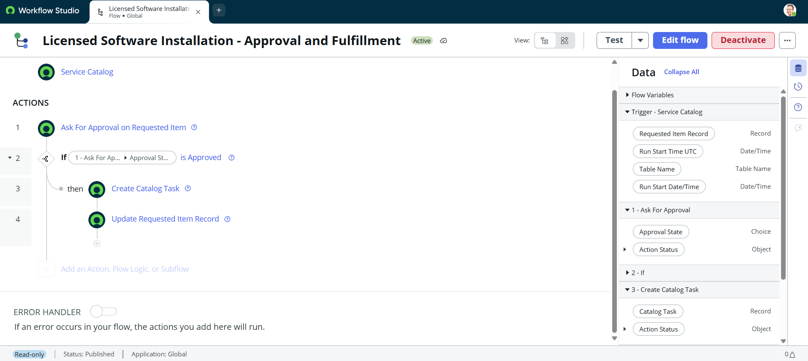
Figure 3: Flow overview — trigger (Service Catalog) and the four core actions.

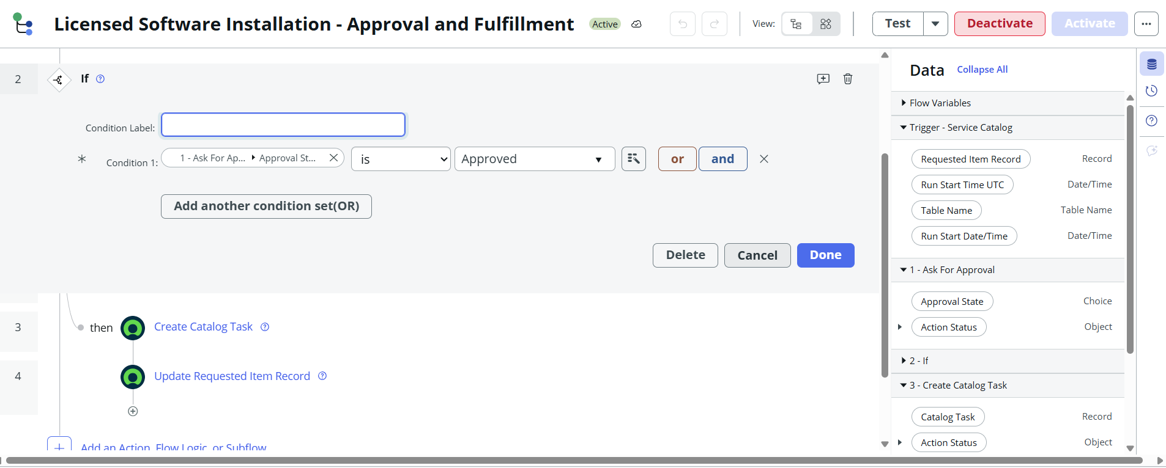
Figure 4: If-condition logic validating that the approval state is Approved.

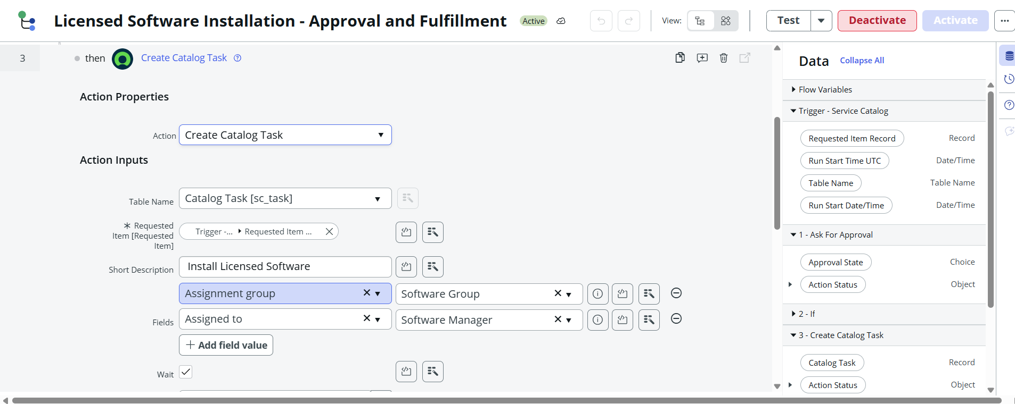
Figure 5: Create Catalog Task action — the fulfillment step, assigned to the Software Group / Software Manager.

4. Setup Instructions

Prerequisites
- A ServiceNow instance (Personal Developer Instance or sandbox) with admin access.
- The catalog_admin role, required to create or modify the catalog item and its variables.
- The flow_designer role, required to build and activate the approval/fulfillment flow.

Installation — Importing the Update Set
All customizations for this project (catalog item, variables, and flow) are captured across the "Licensed Software Installation" and "Licensed Software Installation - Development" update sets. To install the application on another instance:
- On the source instance, open the relevant Update Set and use Export to XML to download the remote update set XML file.
- On the target instance, navigate to Retrieved Update Sets and import the XML file.
- Open the imported Update Set and click Preview Update Set, resolve any conflicts, then click Commit Update Set.
- Verify that the Licensed Software Installation catalog item, its variables, and the approval/fulfillment flow have all been created and the flow shows as Active.

5. Application Structure

Instead of a client/server folder structure, this ServiceNow solution organizes its components by type. The main components created for this project are:

Component | Name / Table | Purpose
Catalog Item | Licensed Software Installation (sc_cat_item) | Employee-facing request form
Flow | Licensed Software Installation - Approval and Fulfillment | Approval routing and fulfillment logic
Requested Item | sc_req_item | Stores each employee's submitted request and its live status
Catalog Task | sc_task — "Install Licensed Software" | Fulfillment task for the IT Software Support Team
Approval Record | sysapproval_approver | Tracks each approval decision (Software Manager)
Update Sets | Licensed Software Installation / ...- Development | Configuration change tracking for deployment

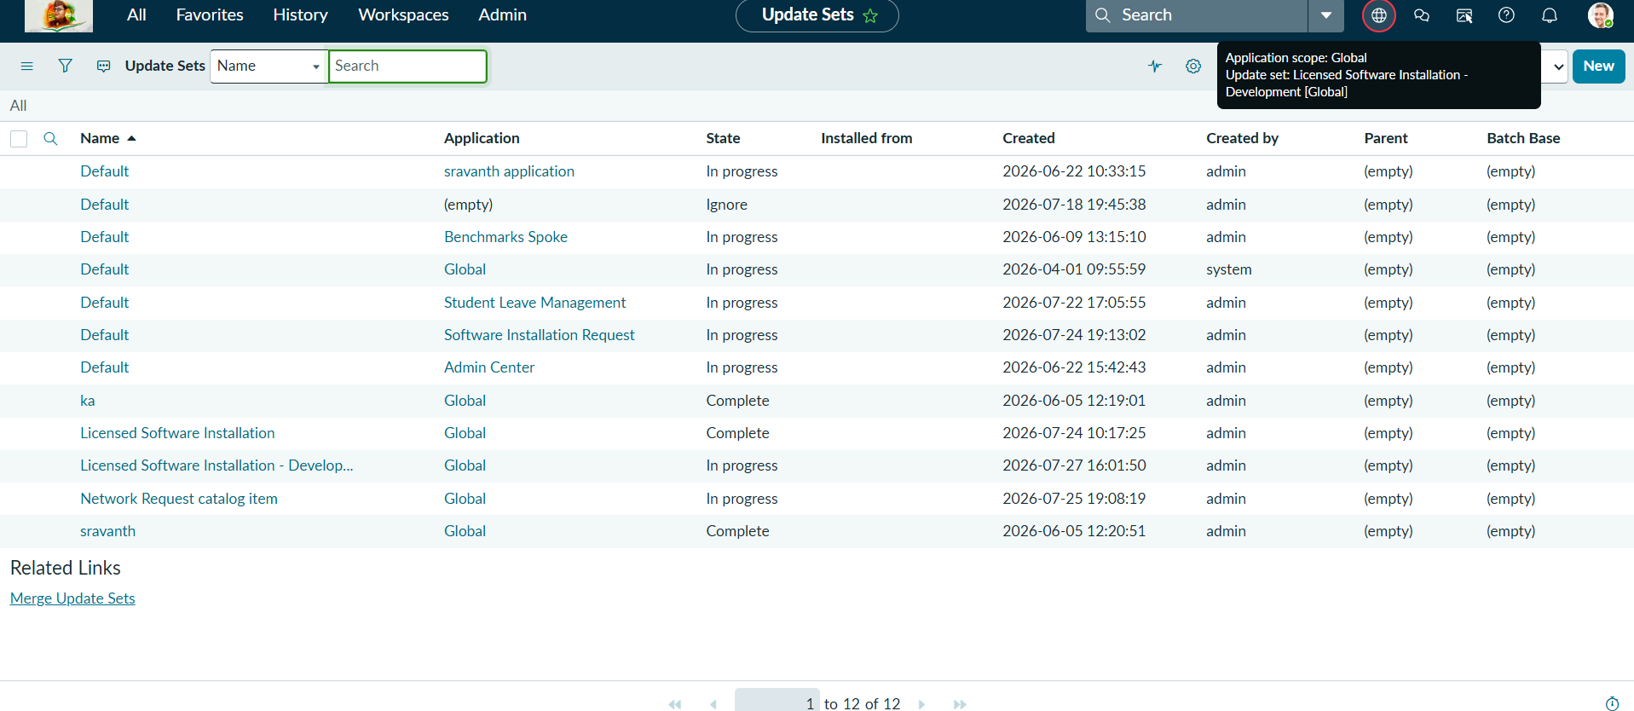
Figure 8: Update Sets list, including the Licensed Software Installation update sets.

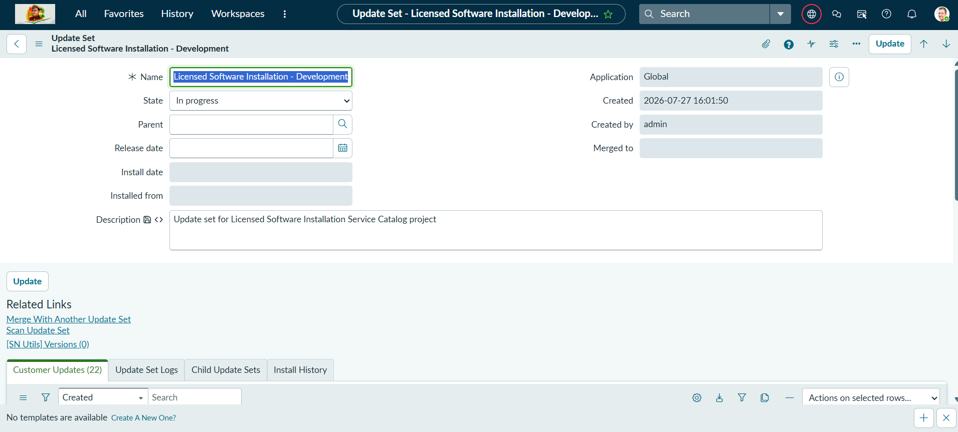
Figure 9: Update Set record — scope, state, and description of the change set.

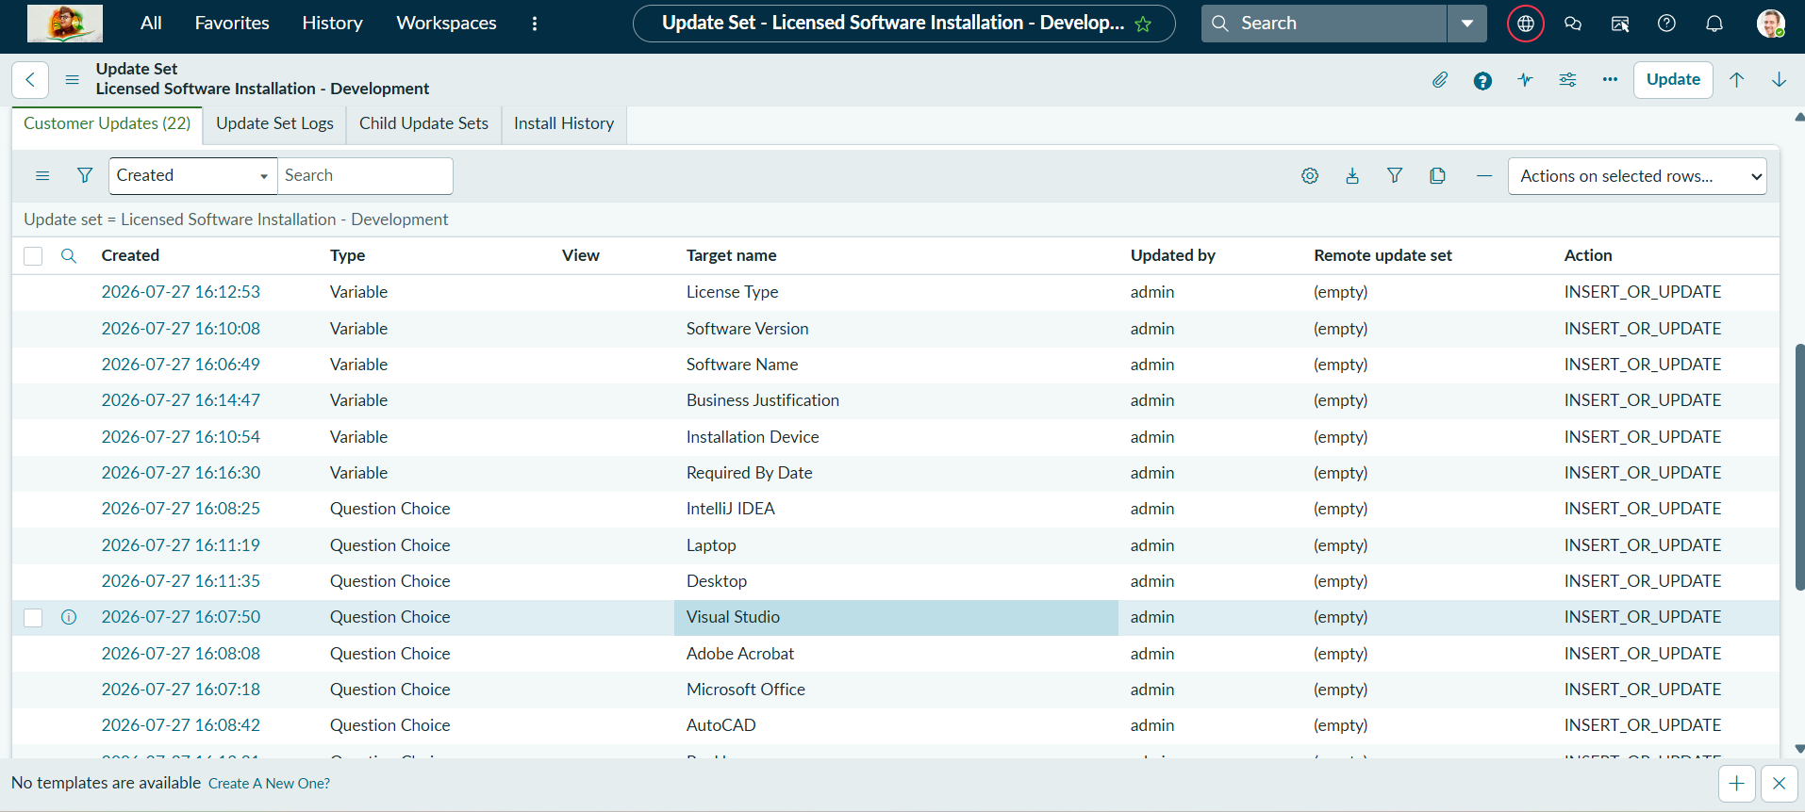
Figure 10: Customer Updates within the update set — every variable and choice value created for the catalog item.

6. Running the Application

There is no separate frontend/backend server to start — the application runs natively inside the ServiceNow instance.
- Employee: opens the "Licensed Software Installation" item from the Service Catalog, fills in the form, and clicks Order Now.
- Software Manager: approves or rejects the request from the Approvals list or the approval notification.
- IT Software Support Team: works the generated Catalog Task once the request is approved.

Once submitted, the Requested Item (RITM) is created and the flow automatically raises an approval. After approval, the RITM shows the live Delivery Plan status for the "Install Licensed Software" task.

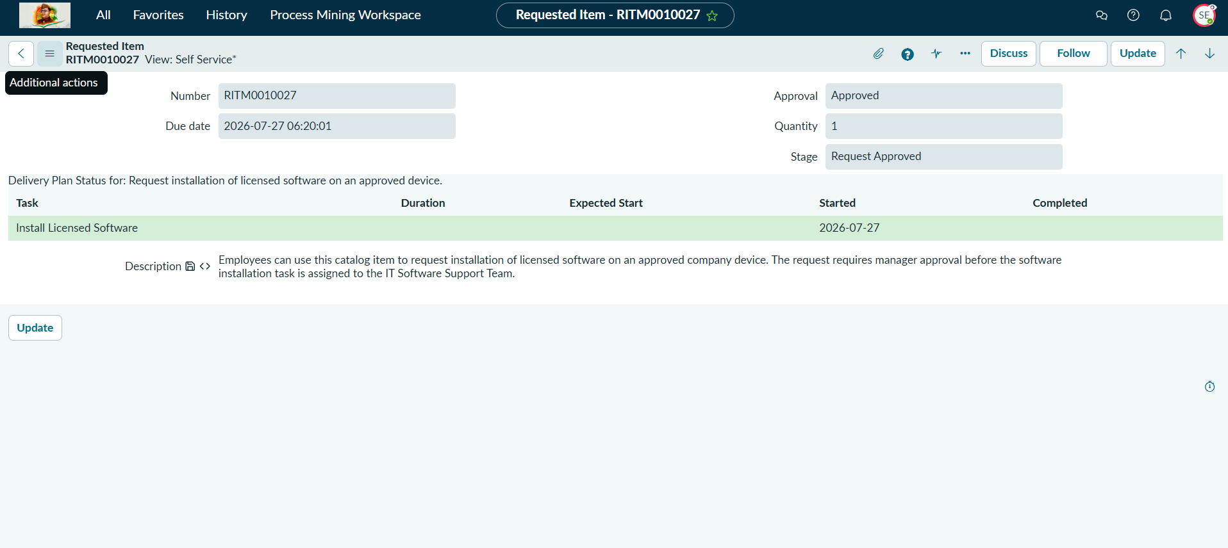
Figure 7: RITM0010027 after manager approval, showing the Install Licensed Software delivery task in progress.

7. Data / API Documentation

ServiceNow does not require hand-written REST endpoints for basic CRUD — every table automatically exposes a REST API (the Table API). The table below documents the operations available and the equivalent UI action that triggers them in this application.

Operation | Table API Method | Triggered From
Create a request | POST /api/now/table/sc_req_item (via Catalog API) | Catalog item order submission
Read a request | GET /api/now/table/sc_req_item/{sys_id} | Opening the Requested Item (RITM) record
Update a request | PUT /api/now/table/sc_req_item/{sys_id} | Flow's "Update Requested Item Record" action
Create fulfillment task | POST /api/now/table/sc_task | Flow's "Create Catalog Task" action
List approvals | GET /api/now/table/sysapproval_approver | Approvals list, filtered by approver

Access to every one of these operations is still governed by ServiceNow's standard Access Control Rules (ACLs) — the Table API enforces the same role checks as the UI.

8. Authentication & Authorization

Instead of JWTs or sessions managed in application code, this project relies entirely on ServiceNow's built-in platform security: native user sessions and standard, out-of-the-box roles rather than custom roles, groups, or ACLs.

8.1 Roles
- catalog_admin — required to create or modify the catalog item and its variables.
- flow_designer — required to build, edit, and activate the approval/fulfillment flow.
- approver_user — allows the Software Manager to act on approval requests routed to them.
- itil — used by the IT Software Support Team to work the generated Catalog Task.

8.2 Access Control
Read/write access to sc_req_item, sc_task, and sysapproval_approver is governed by ServiceNow's standard, out-of-the-box Access Control Rules for those tables. No custom roles, groups, or ACLs were created for this iteration of the project — this is called out as a Future Enhancement below for tighter, request-specific security.

9. User Interface

The end-user interface is entirely native ServiceNow UI — no custom frontend code was written. Two surfaces make up the user experience:
- Employee-facing: the "Licensed Software Installation" Service Catalog Item form, used to submit a new request.
- Manager/admin-facing: the standard ServiceNow Approvals list and the Requested Item (RITM) record, which shows the request details together with its live Delivery Plan status.
Because the form is built with out-of-the-box ServiceNow UI elements (select boxes, single/multi-line text, and a date picker), it automatically inherits the platform's responsive layout, accessibility, and theming.

10. Testing

Testing for this application was carried out manually within the ServiceNow instance, using the following approach:
- Form submission testing: submitting the Licensed Software Installation form with valid and missing field values to confirm mandatory fields (marked with *) are enforced.
- Approval routing testing: confirming the flow correctly routes the request to the Software Manager and that Approved vs Rejected outcomes branch the flow as expected.
- Fulfillment testing: confirming the Create Catalog Task action only fires on approval, with the correct Assignment Group (Software Group) and Assigned To (Software Manager) values.
- Status tracking testing: verifying the RITM's Stage and Delivery Plan status update correctly as the Catalog Task progresses.
- Update Set validation: exporting the update set to XML and re-importing it into a clean instance to confirm the catalog item, variables, and flow all migrate correctly.

11. Screenshots / Demo Summary

Screenshots for every major component are embedded throughout this document, in the section that describes the corresponding feature (Architecture, Setup, Running the Application, and Data/API Documentation). The quick index below lists every figure for reference.

Fig. | Shows
1 | Catalog item variables (Software Name, Version, Device, License Type, Justification, Date)
2 | Employee-facing catalog item request form
3 | Flow trigger and overview of the four core actions
4 | If-condition validating the approval state is Approved
5 | Create Catalog Task action — the fulfillment step
6 | Approvals list showing decisions across multiple software requests
7 | RITM after manager approval, showing the delivery task in progress
8 | Update Sets list, including the Licensed Software Installation update sets
9 | Update Set record — scope, state, and description
10 | Customer Updates within the update set

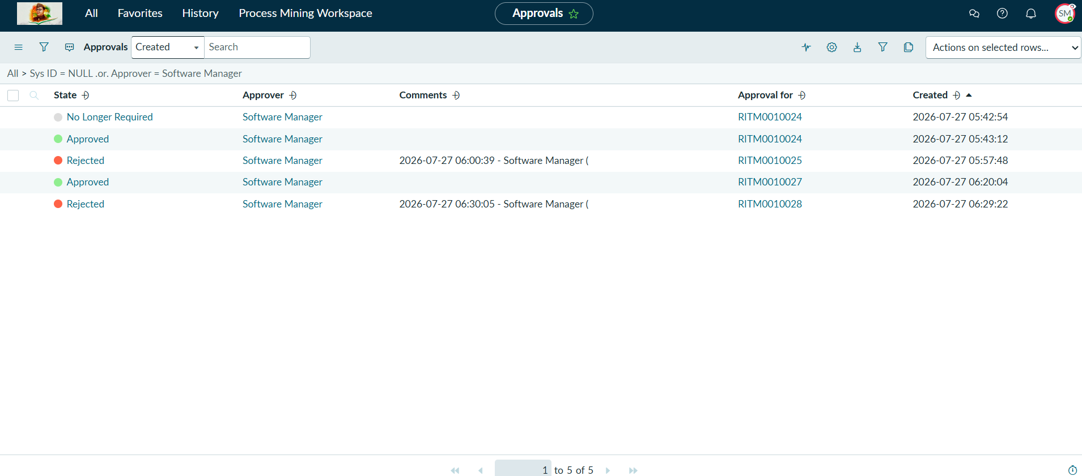
Figure 6: Approvals list showing decisions across multiple software requests.

12. Known Issues

- Software Name and Software Version are free-text/select values without a backing CMDB or Software Model lookup, which can lead to inconsistent naming across requests.
- There is no automated license/seat-availability check before approval — Software Asset Management (SAM) is not yet integrated into the flow.
- All components currently live in the Global scope with standard OOB roles; there are no request-specific custom roles, groups, or ACLs restricting access the way a dedicated scoped app would.
- Rejection reason is captured as free-text comments on the approval record rather than a structured reason code.

13. Future Enhancements

- Integrate Software Asset Management (SAM) to validate license seat availability automatically before approval.
- Add automated fulfillment via SCCM/Intune/JAMF integration so the Catalog Task triggers a real software push instead of a manual IT task.
- Introduce custom roles/groups and request-specific ACLs (similar to an "it employees"/"it manager" model) for tighter access control.
- Add a structured rejection-reason field and an automatic re-submission workflow.
- Build a Performance Analytics / reporting dashboard summarizing requests by software title, status, and turnaround time.
- Add mobile-friendly UI Actions so managers can approve or reject requests directly from the ServiceNow mobile app.

